## Building a Text Command with Fields

Building text commands, with fields, allows for custom navigation through standardized text.

Building a Text Command with Fields

1. Open the Commands window by selecting it from the Control Bar or by stating “Open

Commands” in your microphone.

1. Ensure you have selected the Command Category with your name listed.
2. Select Add in the top right corner of the window.

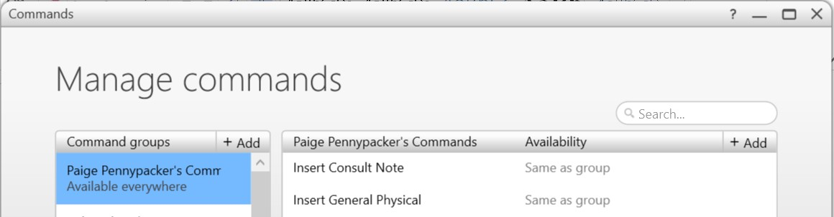

**2**

**3**

1. Once in the Command Editing Window, name your command (as an action) and choose the Text command option to add the text box to your command.
2. Enter the desired text. Place brackets [ and ] in the spaces you’d like custom text to be entered while dictating.

**Note:** You can add space saving reminders within the brackets if you’d like, but you don’t have to. Ex., [sex], [age]

1

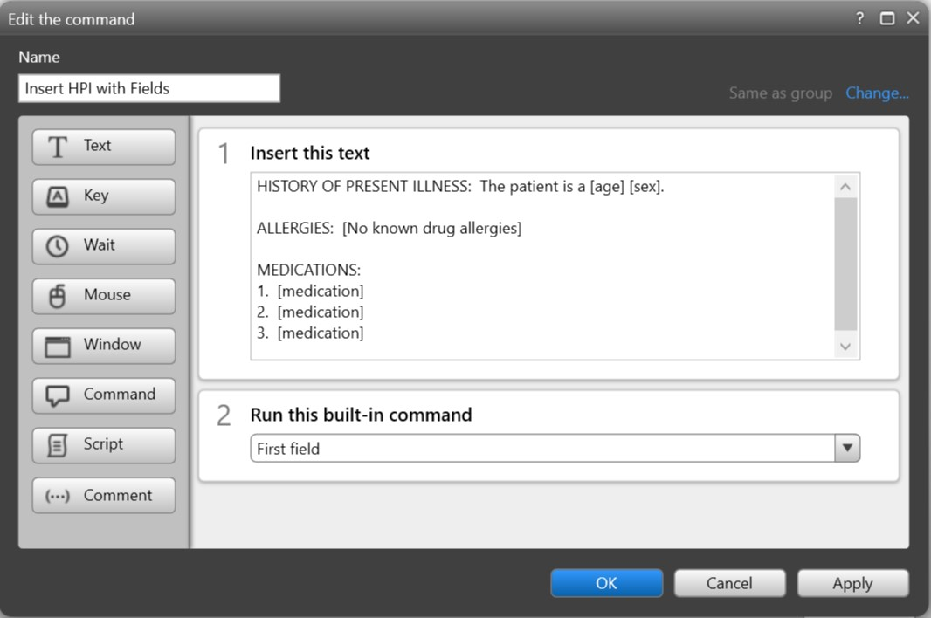

**4**

**5**

**6**

**7**

1. Optional: Choose the Command option and select First field to add the First Field

Command. This will allow FD to default to the first field once the text is inserted.

1. Save your command by selecting OK.

Inserting and Editing your Command

1. Place your cursor in the dictation space (ex: within your EMR, Microsoft Word, or the FD

Speech box).

1. Dictate your command name (ex: Insert HPI with Fields).

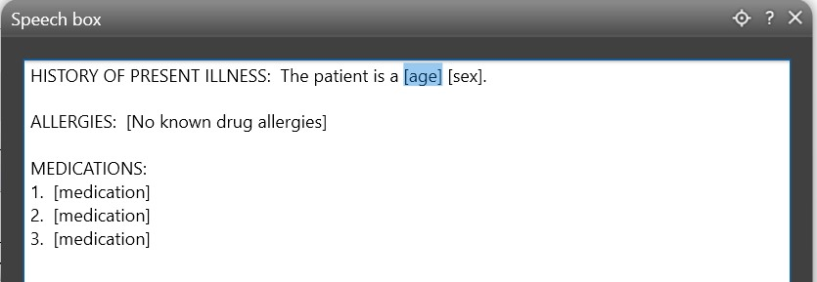

**3**

1. Notice your first field is highlighted. This will only happen if you add the First Field

Command.

1. Dictate Next Field to jump to the next field.

2

1. Once the field is highlighted, dictate within the space.

**Note**: If there is text within the bracket, and it is appropriate, you can continue to the next field by dictating Next Field.

**Note**: You can also dictate Previous Field, and Last Field as needed to jump around between fields.

1. Once all fields are addressed, either the fields are updated or remain the same, dictate

Remove All Fields in order to remove the remaining brackets.

1. Continue with, or save your documentation

3