## Fluency Direct – Linking a Mobile Device

Linking a Mobile Device

Linking a mobile device to your Fluency Direct profile allows for on-the-go dictation from your smartphone when a physical microphone at the PC isn’t present.

Downloading the Mobile Microphone and Linking your Device

1. Visit the iTunes App Store or Google Play store on your smartphone.
2. Install and open the M*Modal Mobile Microphone.
3. On the Welcome screen. Click the Get Started link to begin.

**Note**: You will be prompted to sign into Fluency Direct on your desktop or laptop computer to connect the microphone

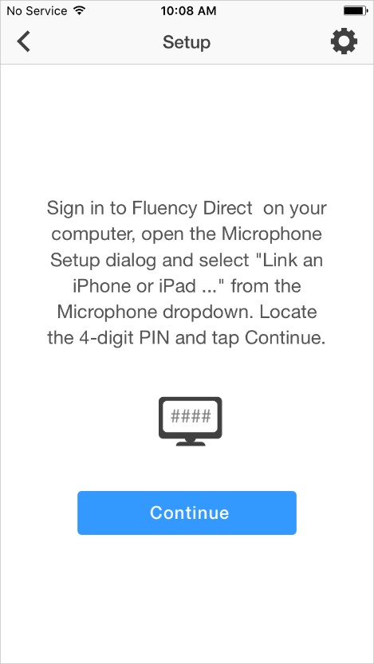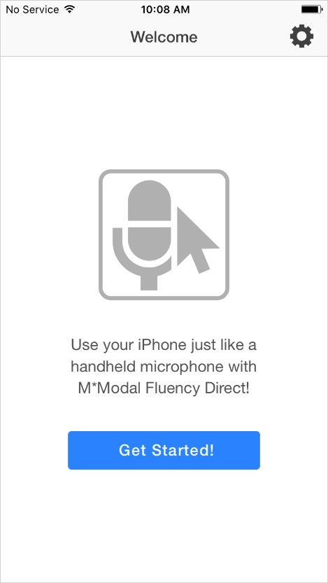

**2**

1. Within Fluency Direct, select Microphone Setup from the Control Bar menu.
2. Select Link a Mobile Device from the Microphone dropdown menu.

**5**

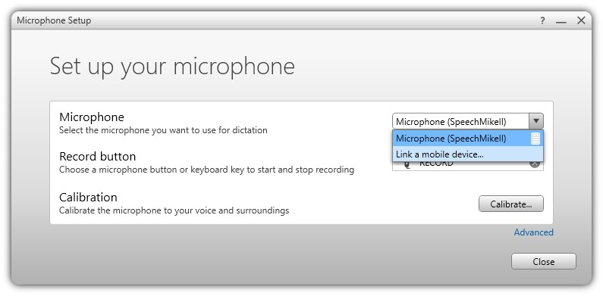

Fluency Direct will present you with a code which serves as a one-time linking between your Fluency Direct User ID and your phone.

**Note**: Any time you load or switch to the Fluency Direct Mobile Microphone on your mobile device, the Mobile Microphone will be treated as a microphone source for the last instance of Fluency Direct logged into with your User ID

**6**

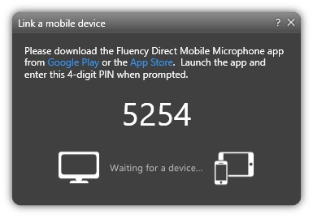

1. Access the Fluency Direct Mobile Microphone from your mobile device and enter the code.
2. Fluency Direct will connect with your mobile device

**Note**: The microphone indicator will display in green when you are dictating

**8**

**7**

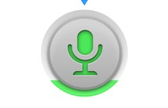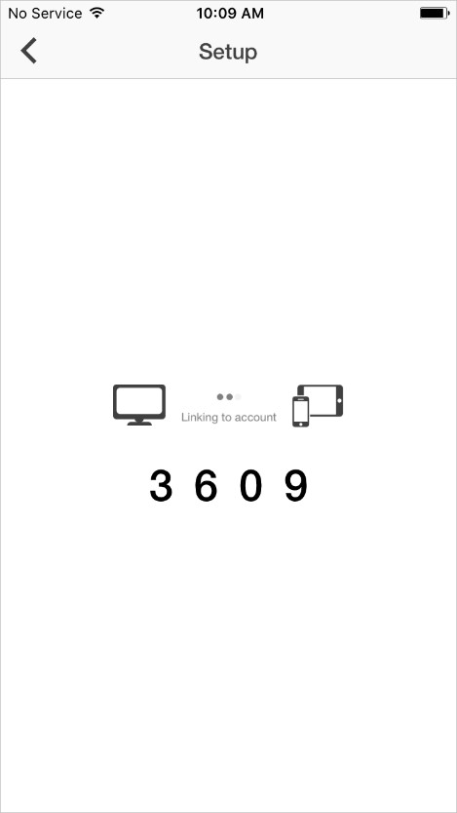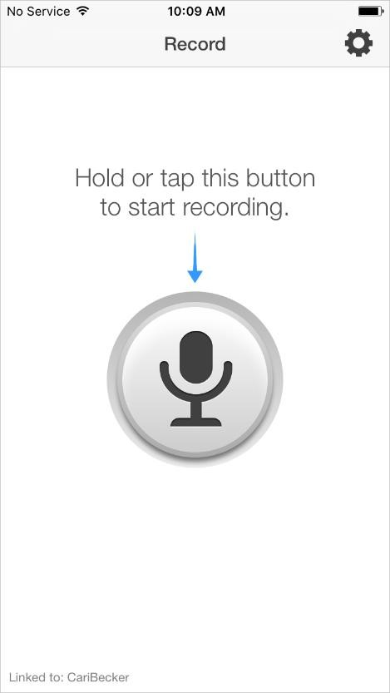

For more information regarding mobile microphone setup, specifications and troubleshooting, visit:

<https://apps.3mhis.com/docs/ClinicianSolutions/MobileMic/en/index-en.html>