## Mapping a Command to a Device Button

Mapping built in or custom commands, and keystrokes to buttons on your device will allow users to quickly execute commands while dictating.

Managing Device Buttons

1. Open the Device Button Mappings window by selecting it from the Control Bar or by stating “Open Device Button Mappings” in your microphone.
2. If set, review your current button utilizations by device, button, action type, and action

**Note:** The lock symbol indicates that only the button action can be modified.

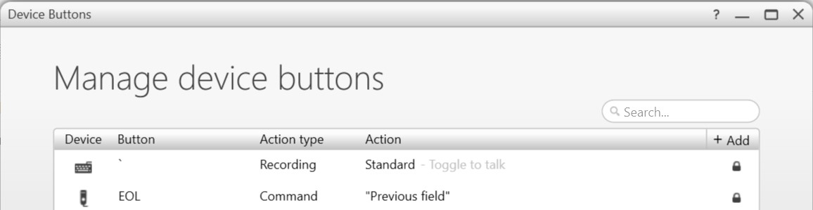

**2**

1. You can either add a new button mapping, or edit an existing button action.

Adding a New Device Button Mapping

1. Select the Add Button on the top right of the Manage Device Buttons screen.

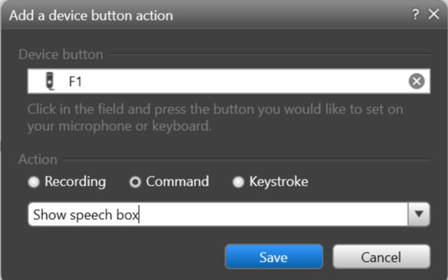

**2**

**3**

**4**

1

1. Place your cursor in the Device Button field, and press the button on your device that you’d like to map.
2. Select an action: Recording, Command or Keystroke. Command or Keystroke will be used most often.
3. Choose the Recording, Command or Keystroke you’d like to map

**Note:** Use the dropdown arrow to find the available actions to map.

1. Select Save

**Note:** Test your button while documenting to make sure it functions as desired.

Editing an Existing Device Button Action

1. Double click the Device Button you’d like to edit.

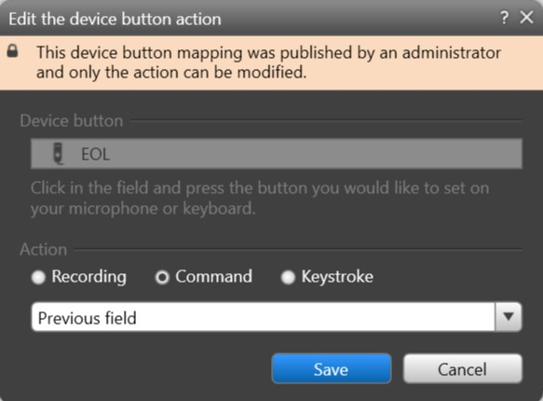

**2**

**3**

**4**

1. If the Device Button was mapped by an administrator, you’re only able to change the action of the button.
2. Select an action: Recording, Command or Keystroke. Command or Keystroke will be used most often.
3. Choose the Recording, Command or Keystroke you’d like to map

**Note:** Use the dropdown arrow to find the available actions to map.

1. Select Save

**Note:**  Test your button while documenting to make sure it functions as desired.

2

2

3