## Setting a dictation target

Users can set windows as dictation targets. Doing so will allow all dictated text to display in the targeted window, even if it’s not the window in focus.

Setting the speech box as a target

1. Open the Speech box window by selecting it from the Control Bar or by stating “Open

Speech box” into your microphone.

1. In the Speech box toolbar, you’ll see a target symbol. Select the target to set the Speech box as a target dictation window. You can also dictate “Set Target Window” into your microphone.

**Note**: You can also set the transparency of the Speech box. This feature allows users to dictate into the Speech box while having documents open behind the Speech box, still visible.

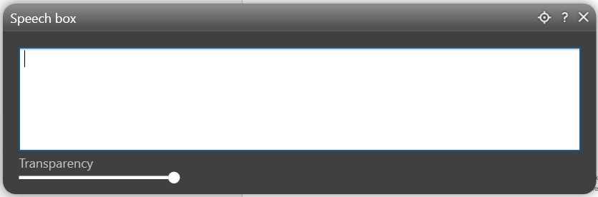

**2**

1. Once the target is set, you’ll see a ribbon, displaying an explanation, as well as the ability to cancel the target setting. You can also dictate “Cancel Target” into your microphone.

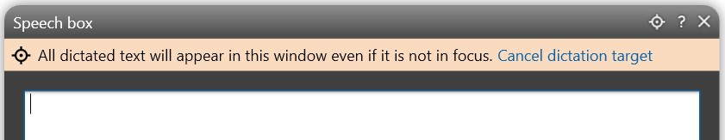

**3**

Setting any window as a target

1. Open the desired application you’d like to set as a target (ex. Microsoft Word, your EMR,

etc.).

1. Set the cursor somewhere in the window you’d like to target, ensuring it’s in focus.
2. Dictate “Set Target Window” into your microphone.
3. Your Fluency Direct Toolbar will display a ribbon that states the name of the window set as the target.



**4**

1. You can cancel the target setting by selecting the “X” within the ribbon, or dictating

“Cancel Target” into your microphone.

**Note**: Closing the targeted window will also cancel the target.