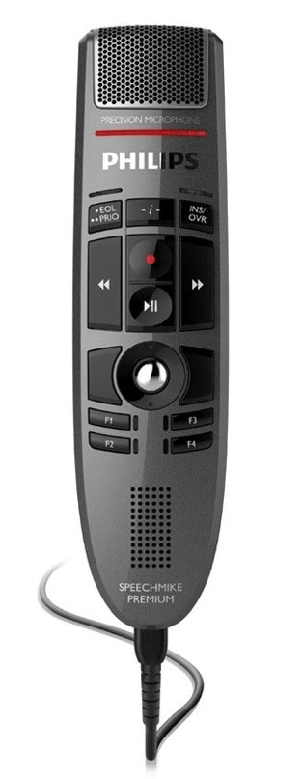

Record

Previous field

Dictate a command

Next field

|  |  |
| --- | --- |
| **DICTATED COMMAND** | **ACTIONS** |
| **Delete that**  **Delete selection** | Deletes selected word(s) |
| **Undo that** | Undoes the last utterance |
| **Correct**  **<text to correct>**  **Correct selection** | A selection box pops up, the user can choose M*Modal’s best guess alternatives or type in a new term for Dictionary training |
| **New line** | Cursor moves down one line |
| **New paragraph** | Cursor moves down two lines |
| **Select**  **<text to select: word, phrase, or sentence>** | Selects specfiic text |
| **Select all** | Selects all text (Ctrl + A) |
| **Save this text** | Brings up a selection box where the user can add a new text snippet command |
| **Next field**  **Previous field** | Moves the cursor to the next or previous fields within line |
| **Remove all fields** | Removes left and right brackets of text |
| **Go to end of sentence**  **Go to end of paragraph** | Moves cursor to the end of the current sentence or paragraph |
| **Insert before <text>**  **Insert after <text>** | Moves cursor before or after specific text |
| **Caps On / Off** | Turns on or off Caps Lock |
| **Show speech box**  **Open speech box** | Launches Speech Box wherever the cursor is located |
| **Transfer Text** | Moves text from the speech box to the note area where your cursor is located |

## Quick Reference

## Common Voice Commands

## Creating Commands

1. Highlight the text you would like to save for later use with the mouse or select the text via voice command (such as **“Select All”**)
2. Say the command **“Save this text.”** This will open the Command Details box.
3. Dictate or type the command name in the Name field. Dictating is preferred to ensure proper spelling.
   1. Use an “action verb” at the beginning of each command name (i.e. "**Insert**", "**Print**", etc.).
   2. Make sure the command is more than one word. (i.e. “Insert physical exam”)
4. Click **OK** to save the command
5. The exact Name of the command must be dictated to have it execute i.e. “Insert physical exam”, not just “Physical exam”
6. To see all of your personal commands, click on the **Control Bar (your name) > Commands** or say **“Open commands.”** Here you can create new commands or edit existing ones.
7. Highlight or speak the command **select <text>**
8. Once text is highlighted, speak the command **“Add to Dictationary”** whilst holding the play/pause button. This will automatically add the word to the dictationary.
9. Once the dialogue box appears, ensure the word has the correct capitalization.
10. Select the proper category and adjust the pronunciation if needed.

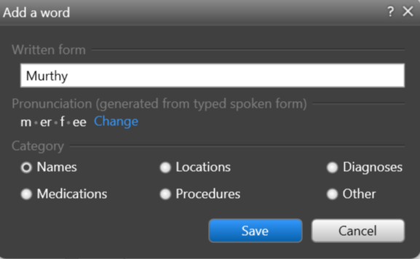

1. To see all of your personal dictionary terms, click on the **Control Bar (your name) > Dictionary** or say **“Open dictionary.”** Here you can create new dictionary terms or edit existing ones.

## Creating Dictionary Entries

* Recalibrate your microphone if you experience a decrease in recognition quality. This could be due to a change in dictation environments.
* Use correct verbiage and grammar – speak in full sentences and include punctuation.
* Enunciate words that can be misunderstood (i.e. abduction vs. adduction)
* Release the RECORD button when pausing.
* Hold the device approximately 4-6 inches off to the side of your mouth.
* Edits not only ensure accurate documentation, but also enables Fluency Direct to learn and improve recognition quality.
* To edit text, say **“select <text>”** and speak over highlighted text.
* The Fluency Direct speech engine assumes that you will edit mistakes, not doing so can result in continued recognition concerns.
* Edits can also be made by using the keyboard and mouse. Fluency Direct is flexible in that it will learn from any type of correction.

## Editing

## General Good Habits

## Quick Reference