Plymouth University Trust Stroke- A training Document (A Shah, A Mohd Nor, E Abelgadir, W Lim, S Weatherby)

A stroke is a sudden, focal neurologic deficit that lasts for more than 24 hours resulting from tissue damage caused by blockage of blood flow (infarction) or rupture of an artery (haemorrhage) to the brain or the eye.

A TIA was historically defined as a sudden, focal neurologic deficit that lasts for less than 24 hours, presumed to be of vascular origin, and is confined to an area of the brain or eye perfused by a specific artery. This is now considered to be out of date as MRI scans show that if a deficit lasts more than an hour there is often a small area of damage- i.e. it is a small but resolving stroke

New TIA definition. A transient episode of neurological dysfunction caused by focal brain, spinal-cord, or retinal ischemia, without acute infarction. In practice a true TIA tends to last less than an hour.

You may notice that the definition of stroke also needs updating: what about patients who have symptoms for less than 24hrs but have evidence of damage on brain scans? Pathologically they have had strokes and we are moving away from symptom duration, especially if the scan shows established damage.

Demographics

There are endless demographics; these should help you get a feel for the condition
Incidence approx. 1 per 1000per year
75% of strokes occur in the over 65‘s
Third. commonest cause of death, responsible for 12% of deaths in UK 24% of stroke sufferers are left with severe disability
Twice as frequent in African-descent women than Caucasian women (US data)

Stroke Classification

First need to establish whether a stroke is ischemic (85%) or haemorrhagic (15%) - a CT scan will rapidly answer this question

Where do ischemic strokes come from?

Non-embolic

1) Small vessel disease: intracranial arterial damage leads to plaque formation and in-situ thrombosis- this is often the mechanism for smaller strokes (lacunar infarcts). The causes for this are shared amongst all atherosclerotic disease (e.g. diabetes, hypertension, smoking) and should be investigated accordingly.

2) Other: rarely haematological disorders may predispose to in situ thrombosis. In practice, this is rare, but may be seen in some hyperviscosity syndromes. Most thrombophilias (e.g. Factor V Leiden mutation) predispose to venous thrombosis, not arterial thrombosis

Embolic sources:

Carotid atherosclerotic disease (carotid stenosis): plaque accumulates in the internal carotid arteries. This may embolize distally to the brain or eye, particularly in the case of plaque rupture. Patients with 50%-99% stenosis of the internal carotid artery and a recent ischemic event should be considered for carotid endarterectomy. If the artery is occluded it is ‘secure’ from distal embolization and the risk of stroke is significantly reduced: these patients therefore do not require endarterectomy (N.B. this only applies if the vessel has occluded over time and collateral vessels have had time to form: sudden occlusion will cause a large stroke and reperfusion should be attempted with thrombolysis or thrombectomy).

Cardio-embolic: Most commonly due to atrial fibrillation (AF). Risk of stroke can be estimated using CHADS-VASC score but can be >10% per year. Important to diagnose as anticoagulation significantly decreases the risk of stroke. Rarer causes include atrial myxoma, infective endocarditis and structural cardiac disease, such as PFO. PFO can give rise to a ‘paradoxical embolus’- a clot forms in the venous system (e.g. DVT) then crosses in to the arterial system through the PFO, to distally embolize to the brain.

Cervical arterial dissection: Vertebral and carotid arteries can become dissected. Platelets aggregate on the dissection flap to repair the tear. These may break-off and embolize distally. The lumen of the vessel may also fully occlude, impairing blood flow in the proximal vessel. Horner’s syndrome may accompany both carotid and vertebral dissections. This is caused by interruption of the sympathetic neurons which travel along the internal carotid artery (interrupted by the dissection itself) and in the brainstem (damaged by the infarct resulting from vertebral dissection). Dissection is normally associated with acute severe pain and it may be secondary to trauma. Dissections tend to occur in younger patients (most commonly in the 5th decade). Treatment is with antiplatelets and often the vessel recanalizes in a few months with low risk of recurrence.

Other embolic sources: atherosclerotic plaque in the aortic arch may embolize to the brain.

Haemorrhagic

Hypertensive- most common type, typically affecting the deep brain structures, such as the basal ganglia and thalamus

Secondary to cerebral amyloid angiopathy (CAA). Patients with CAA have intracranial arteries which are more liable to rupture and cause ‘lobar haemorrhages’. These tend to involve the cerebral cortex. Patients with CAA are at high risk of recurrent haemorrhage

N.B. ruptured intracranial aneurysm, arteriovenous malformation, cerebral venous sinus thrombosis and trauma can cause intracerebral haemorrhage, but these are generally not considered to be strokes.

Young people and stroke

Don‘t forget young people can also have strokes too (obviously it‘s rare). The approach to causation is different. Generally, consider:
- Haematological problems (e.g. anticardiolipin and lupus anticoagulant procoagulant disorders)
- Systemic autoimmune inflammatory conditions/vasculitis.
- Drug causes e.g. cocaine, amphetamines.
- Arterial dissections.
- Cardiac conditions (structural e.g. endocarditis, patent foramen ovale, or arrhymogenic)
Cervical artery dissection is a significant cause of stroke in patients younger than 40 years. Dissections usually are subadventitial (between the media and adventitia or within the media), creating a false lumen that can cause stenosis, occlusion, or pseudoaneurysm of the vessel. Simultaneously, the dissection may cause the formation of a thrombus from which fragments embolise. Strokes resulting from carotid dissection thus may have a haemodynamic or embolic origin. A major clue to a carotid artery dissection is a Horner’s Syndrome. Horner’s Syndrome is caused by damage to the sympathetic supply to the eye (these travel alongside the carotid artery). A Horner’s syndrome consists of ptosis, miosis, enopthalmos, and sometimes anhydrosis. It is important to consider a carotid dissection in any case of painful Horner’s syndrome. If there is an arterial dissection always thinks why, e.g. was there trauma? do they have a connective tissue problem like Ehlers Danlos syndrome?

Rather than a standard ECHO, it is often necessary to do more detailed cardiac imaging- e.g. transoesophageal ECHO with bubble studies (this looks at ‘holes in the heart‘ like patent foramen ovale better). Other tests that might be appropriate include MRI scan of brain, sickle screen, serum homocysteine, serum lactate, drug screen, lumbar puncture, cerebral angiography.

Genetics of Young Stroke

Familial Gene Clinical tips

CADASIL Notch 3 (cerebral autosomal dominant arteriopathy with subcortical infarcts and leukoencephalopathy)

CARASIL HTRA1 like CADASIL but autosomal recessive and joint degeneration

TREX1 (AD) Stroke, migraine and retinal degeneration

COL4A1 (AD) COL4A1 Infantile hemiparesis, migraine, haemorrhage, Raynaud’s.

(Ask about apparent birth injury if migraine and small vessel disease)
Clues when assessing a patient with suspected stroke
Questions to bear in mind:

- Is it a stroke or a mimic?
You will need a good understanding of the most frequent stroke mimics. These are migrainous auras and focal seizures. Migrainous auras can manifest with aphasia, hemi-paraesthesia, visual disturbance (commonly flashing lights) and rarely hemiparesis. Some seizures can look like TIAs (e.g. an aphasic seizure) but more commonly, it is the patients who develop a Todd’s palsy who are mistaken as having a stroke. A Todd’s palsy follows a focal seizure: the seizure ‘stuns’ the part of the brain which has generated the seizure and causes very convincing focal symptoms which can last for several hours. Bearing this in mind, ask yourself:
- Are the symptoms positive (paraesthesia, flashing lights) or negative (numbness, loss of vision)? Positive suggest migraine or seizure, negative suggests stroke. N.B. except Todd’s which is negative.
- Are the symptoms sudden in onset, all coming on at the same time or migratory (e.g. spreading sensory disturbance). Spreading symptoms goes against vascular aetiology
- Are the symptoms recurrent and stereotyped- generally this would suggest an alternative diagnosis, such as focal seizures. However, do not forget crescendo TIAs due to unstable carotid plaque: this may cause recurrent emboli to the same side of the brain, breaking this rule.
- Are the symptoms common stroke symptoms? Note blackout is an uncommon stroke symptom and almost never caused by a TIA. Remember symptoms and signs should be focal. Confusion, generalized weakness and slurred speech can occur with a wide variety of medical conditions and are not specifically neurological, although they may be.
- Are the symptoms anatomically congruous/ possible? Remember 97% of right handed people are left hemisphere dominant. Therefore, if a right-handed patient has aphasia and right sided weakness, they are either in the 3% (unlikely), have bilateral infarcts (unlikely but possible) or do not have a stroke (most likely!).

- Are they ill with a stroke complication?
- aspiration pneumonia, raised intracranial pressure, fitting (beware subclinical seizures or status epilepticus in unconscious patient)

- Why did they have a stroke? There may be clinical clues
- Retinal changes with hypertension, bruits carotids, atrial fibrillation, , cholesterol xanthelasmata, Always consider the possibility of temporal arteritis and consider doing an ESR blood test.

- Where is the stroke?
Anterior or posterior?

Anterior Vs Posterior
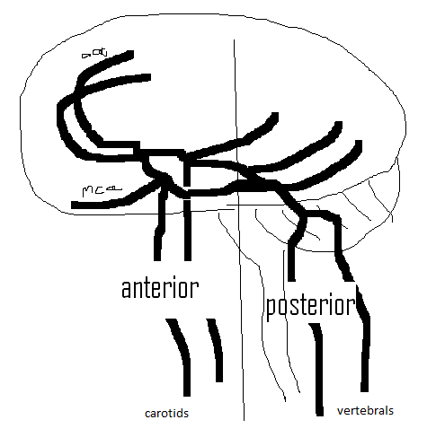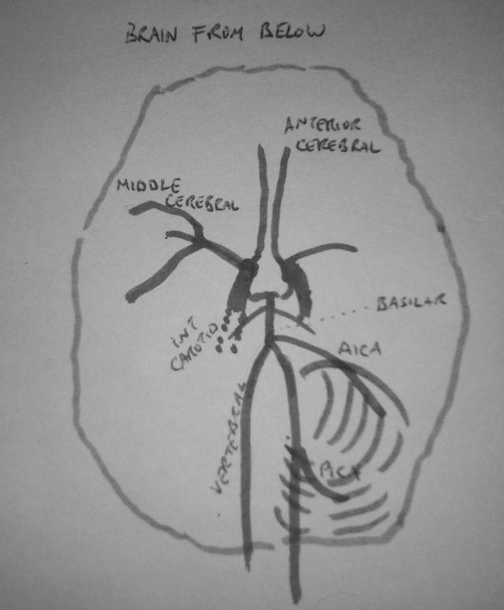

The posterior circulation is the vertebra-basilar system which gives rise to the cerebellar arteries and the posterior cerebral arteries. This supplies the brainstem, cerebellum, occipital lobes, the infero-posterior temporal lobes and the thalamus. Everything else is termed the anterior circulation.

Anterior signs | Posterior signs | Occur in either
Expressive aphasia | Signs in all 4 limbs | Dysarthria
Receptive aphasia | Diplopia | Hemiparesis
Isolated weakness (e.g. just an arm or leg) | Severe/ isolated dysphagia | Hemi-numbness
Apraxia | Vertigo | Hemianopia (unless isolated, which is post.)
Inattention | Impaired conscious level
 | Impaired co-ordination

Remember the cerebellar signs: DANISH?
Dysdiadochokinesia, Ataxia, Nystagmus, Intention tremor, Slurred or Staccato speech, Hyporeflexia

Left vs right vs bilateral?

• Hemiparesis/ hemi-numbness is contralateral to the stroke as it will occur above the decussation of the pyramids.
• In right-handed patients the left hemisphere is dominant for language in 97% and roughly 75% in left handed patients.
• Severe neglect (especially if isolated) tends to localize to the non-dominant hemisphere.
• Homonymous visual field defect- stroke is on the other side to the visual loss.
• Cerebellar signs tend to be ipsilateral (left cerebellar stroke causes nystagmus predominantly to the left, left intention tremor etc.)
• Bilateral signs due to stroke tends to localize to the brainstem: there is only one basilar artery so if this is occluded it will cause damage to both sides of the brainstem.
• Rarely simultaneous strokes can occur in different parts of the brain, causing signs that can’t be put down to one vascular territory (e.g. diplopia and expressive aphasia).

Cortical vs subcortical

If the cortex is damaged this affects the ‘higher cortical function’. Think about what the different regions of cortex do in different lobes and you will be able to figure out what ‘cortical signs’ are: left frontal lobe- expressive aphasia, left temporal lobe- receptive aphasia, right parietal lobe- neglect, occipital lobes- visual field defect etc.

If the subcortical structures such as the internal capsule are affected, there will be no cortical signs. The subcortical structures predominantly carry motor and sensory fibres to and from the cerebral cortex so will cause weakness or numbness, alone or in combination.

The importance of differentiating cortical from subcortical is that emboli (e.g. coming from the heart or carotid arteries) tend to cause cortical infarcts, whereas small vessel disease tends to cause subcortical strokes. This is important because it would be more important, for example, to request a 24hr tape to look for AF in a patient with a left cortical frontal infarct causing an expressive aphasia than somebody with a subcortical infarct in the internal capsule.

Ischemic stroke classification

Armed with the information above you should now be able to use the Bamford stroke Classification of Stroke:

Bamford Classification of stroke adapted from Bamford et al; Lancet 1991; 337
:1521-6)

- Total Anterior Circulation (TAC)
Combination of "3 of 3" of:
- weakness (+/- sensory deficit) of at least 2 of 3 body areas (face/arm/leg)
- homonymous hemianopia
- higher cerebral dysfunction (dysphasia, dyspraxia commonest)

- Partial Anterior Circulation (PAC)
- 2 of 3 of TAC criteria (e.g. hemiparesis and aphasia but no hemianopia) or higher cortical function alone (e.g. isolated aphasia).

- Lacunar (LAC)
- Complete or incomplete weakness of 1 side, involving the whole of 2 of 3 body areas (face/arm/leg)- pure motor
- Pure sensory
- Sensorimotor

- Posterior Circulation (POC)
Affecting brainstem, cerebellar or occipital lobes
Principles of Acute Stroke Management

Acute Stroke is a medical emergency because establishing reperfusion as quickly as possible in ischemic stroke if presenting acutely significantly reduces the chances of being left disabled by the stroke. The treatment options are intravenous thrombolysis if within 4.5hrs or mechanical thrombectomy if within 6hrs. Thrombectomy is less available than thrombolysis and not all patients are suitable. Prompt diagnosis of haemorrhagic stroke may facilitate potentially life-saving surgical intervention. Obtaining a CT scan rapidly will differentiate ischemic and haemorrhagic stroke. If there is a haemorrhagic stroke, it will be visible on a plain CT immediately. Infarcts however often take several hours to be visible on plain CT. The purpose of the CT is to exclude haemorrhage so IV thrombolysis can be given. Often, if an infarct is clearly visible on a plain CT head, it indicates that the brain is already infarcted and attempting reperfusion is likely to be futile. MRI brain scans are much more sensitive at identifying ischemia than CT, especially if affecting the posterior circulation but this is less readily available, and the scan takes longer, limiting its use in hyperacute stroke management, where time is crucial.

Ischemic stroke

- Consider giving IV thrombolysis if the patient has a disabling stroke within 4.5hrs of symptom onset and no contraindications. A non-exhaustive list of contraindications includes evidence of cerebral haemorrhage on CT, coagulopathy, current hypertension (SBP >180), recent surgery and previous cerebral haemorrhage. Mechanical thrombectomy is performed during cerebral angiography (like a primary PCI). An angiogram is performed, the clot is identified and is either pulled out using a wide array of devices, dissolved with local thrombolysis via a catheter or it is aspirated. In practice patients are often given thrombolysis then taken directly to the angio suite and an attempt is made to extract the clot. We do not ‘wait and see’ if the clot dissolves with thrombolysis as large clots often do not with drugs alone and mechanical thrombectomy is much more likely to succeed. There are trials currently underway looking at primary thrombectomy, i.e. if it is available, should patients receive thrombolysis at all or just go straight for thrombectomy. The current criteria for thrombectomy are:
- Onset time: Until recently patients have needed a stroke onset of less than 6 hours. It is now emerging that some groups of patients who are highly selected via advanced imaging modalities may benefit up to 24hrs post onset, so this is likely to change in the future.
- Before going for angiography a clot needs to be demonstrated on a non-invasive scan, almost always CT angiography. This can easily be performed at the time of the initial CT head. The clot must be in a proximal large artery- the proximal MCA, the ICA or the basilar artery.

If acute reperfusion is not possible, treatment should be started with aspirin 300mg. This generally continues for 2 weeks at this dose before switching to clopidogrel 75mg to take indefinitely or an anticoagulant if in AF. Anticoagulation is best avoided in the first 2 weeks after a stroke. Fresh infarcts are prone to haemorrhagic transformation and this can be precipitated by anticoagulation. The risk is proportional to the size of the infarct, so if it is a very small infarct, we can consider anticoagulation sooner, but this decision should be taken by a senior stroke physician. Atorvastatin 20-80mg is started acutely in all patients unless contraindicated with acute ischemic stroke. The target total cholesterol should be <4mmol/l. Acutely, blood pressure should generally not be lowered. The concern is that this may impair cerebral perfusion and worsen cerebral ischemia. Conversely, uncontrolled hypertension may worsen cerebral oedema and increase risk of haemorrhagic transformation. Trials are currently underway investigating whether acute blood pressure lowering in ischemic stroke is beneficial. If the patient is in atrial fibrillation, anticoagulation with either warfarin or a DOAC should be considered 2 weeks post ictus. Any patient with a TIA or stroke will have a CHADS-VASC score of greater than 2 and should be offered anticoagulation unless contraindicated.

Standard work up in ischemic stroke

• 12 lead ECG- check for AF
• Bloods to include lipids and a diabetes test (e.g. HBA1C)
• Carotid doppler if anterior stroke
• ECHO- check for structural heart problems which could cause stroke (especially if embolic stroke)
• Prolonged ECG monitoring (24hr- 7-day tape)- check for evidence of paroxysmal AF

Other tests which may be considered

• CT/ MR angiography- useful to visualize posterior arteries which may be difficult to assess with Doppler. Will allow diagnosis of vertebral dissection. Also allows visualization of intracranial arteries, which can’t be seen on Doppler
• Bubble ECHO- will allow detection of right to left shunt, such as PFO
• Further bloods- rare causes of stroke include vasculitis (ANA, ANCA etc.), antiphospholipid syndrome (anti-cardiolipin, LAC) and rarely infections such as syphilis.
• Trans-oesophageal ECHO- allows better views of the heart but main use acutely is if there is concern of bacterial endocarditis (may cause septic cerebral emboli leading to stroke
• Urine toxicology: especially if stroke occurs in the absence of risk factors. Cocaine is most commonly implicated.
• There are some rare conditions which cause stroke at young ages which can be diagnosed through genetic testing. Fabry disease is one such condition which can also present with cardiomyopathy, renal failure and dermatological manifestations. The mutation causes alpha-galactosidase deficiency, which can be replaced.

Haemorrhagic stroke

More likely to have a lower GCS, so may require airway support/ critical care. If the patient is anticoagulated this should be reversed immediately. If the patient is on warfarin a combination of vitamin K and prothrombin complex concentrate (e.g. Octaplex) should be used after discussion with haematology. Dabigatran can be reversed using idaricuzimab(Praxbind). Platelet transfusion should not routinely be given to patients who have had intracerebral haemorrhages on antiplatelets. Contrary to ischemic stroke, there is good evidence to support lowering blood pressure to a target of 140 systolic for the first seven days post stroke ictus. This is usually done with an intravenous agent such as labetolol or GTN. If a patient is found to have an intracerebral haemorrhage which is not in a typical location for a hypertensive bleed further imaging, such as CT angiography, venography or catheter angiography should be considered. Vascular abnormalities that can cause ICH include aneurysms, arterio-venous malformations, venous sinus thrombosis and cavernomas. Some neoplastic lesions may also present as haemorrhagic lesions (i.e. patients bleed in to a tumour). It is therefore generally recommended that patients with haemorrhagic stroke of uncertain cause undergo a delayed scan to re-image the brain once the blood has resorbed.

Role of neurosurgery in Stroke management

Much surgical management is focused on controlling intracranial pressure. The skull is a fixed volume and unless it is opened the pressure within it is dependent upon the volume of the brain, the CSF and the blood. This is known as the Monro-Kellie doctrine. The volume of the brain can be decreased with steroids, but these are not of proven benefit in stroke and should not routinely be used. Other agents such as mannitol or hypertonic saline are generally reserved for life threatening situations and are used in critical care. The CSF volume can be influenced by CSF drainage. Options to decrease the volume of blood in the skull are limited as this would often involve dropping the cerebral perfusion although some haematomas can be surgically removed.

Ischemic stroke

Patients with large anterior circulation infarcts (TACI) are prone to developing cerebral oedema, which tends to be most severe around 72hrs after ictus. This can cause significant raised intracranial pressure and puts the patient at risk of brain herniation. This is known as the malignant MCA syndrome. This tends to be particularly severe in younger patients as the brain is less atrophic so there is less room for the brain to swell within the skull. In these cases, patients can undergo decompressive craniectomy: removing a large piece of skull overlying the infarct and allowing the brain to herniate/ swell through the skull defect. This is life-saving surgery but the decision to operate needs to be carefully considered: patients will almost always be left severely disabled because of their stroke and fixing the defect via cranioplasty is difficult and associated with severe morbidity/ mortality. The posterior fossa is much smaller and there is very little room for swelling. Posterior fossa craniectomy can be undertaken in these patients. These patients should be managed proactively rather than reactively: if they have evidence of a large infarct they should have close neuro-observation and should be discussed with neurosurgery early, not waiting until they deteriorate. There should be a very low threshold for re-scanning patients who are considered surgical candidates.

Haemorrhagic stroke

Craniectomy can also be performed in haemorrhagic stroke. In addition to this, some haematomas can be surgically removed without leaving a significant skull defect. More peripheral, lobar, bleeds are more likely to be amenable to surgery than deep hypertensive bleeds. There is no strong evidence to suggest that haematoma evacuation improves outcomes and surgery is usually undertaken to reduce the mass effect to lower intracranial pressure. There should be a low threshold for discussion with neurosurgeons. If the haemorrhage extends in to the ventricle (intra-ventricular haemorrhage) the patient is at risk of hydrocephalus. An external ventricular drain can be inserted surgically and can drain CSF, effectively treating hydrocephalus. This is normally a short-term measure and if the patient remains ‘drain-dependent’ they may require definitive ventriculo-peritoneal shunting. Further surgery will also depend upon the source of the haemorrhage and the presence of a vascular malformation, such as an aneurysm or AVM. These malformations can often be treated endovascularly (by specialist neuro-radiologists), although surgery may occasionally be required.

Stroke Units

Stroke units work (37% reduction in mortality if admitted to one, which is as good as primary angioplasty in MI). It is therefore the target that every patient, regardless of age, stroke severity and whether they have undergone reperfusion therapy should be managed on a stroke unit. Closer control of BP, careful control of blood sugar, temperature, calorie intake, early physiotherapy and early recognition of complications are all important.

Getting Better

- Most recovery in first 3 months
- 10% of recovery between 6 months and 1 year. Very little recovery after one year
- 32% of stroke survivors clinically depressed (slightly more than myocardial infarct survivors). All patients should be screened for mood disorders
- Patients with large neurological deficits will often undergo rehabilitation in designated stroke rehab units. There is now a trend towards delivering rehabilitation in the community via early supported discharge teams (ESD). Therapists visit patients at home to deliver therapy.
- For spasticity agents such as baclofen, tizanidine and gabapentin are often used. Botulinum toxin (BTX) injected in to specific muscles may be preferable as it does not cause systemic side effects. Needs to be used selectively to alleviate painful spasticity or to relax individual muscles to allow increased range of movement to facilitate specific functions (e.g. armpit hygiene, dressing). The benefits of improved range of movement need to be balanced against the likelihood of increasing weakness in the injected muscle.
- Strokes can cause cognitive disorders beyond classical ‘vascular dementia’. Cortical damage can cause a wide range of cognitive disorders such as receptive aphasia, acalculia, apraxia and alexia which can pose real difficulties for patients who may be fully mobile. This may be a barrier to independent living. Occupational therapists, speech and language therapists and clinical psychologists can aid recovery of deficits and provide patients with strategies to help cope with these deficits. Some subcortical structures such as the thalamus can also cause severe cognitive problems if damaged.

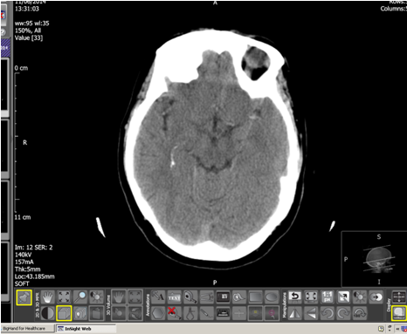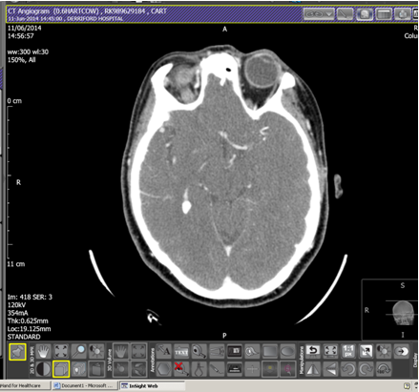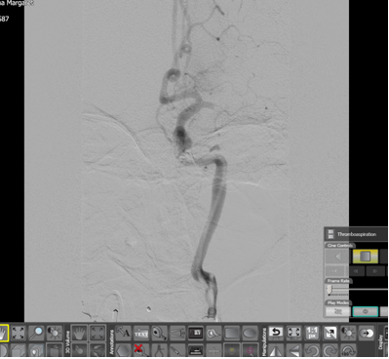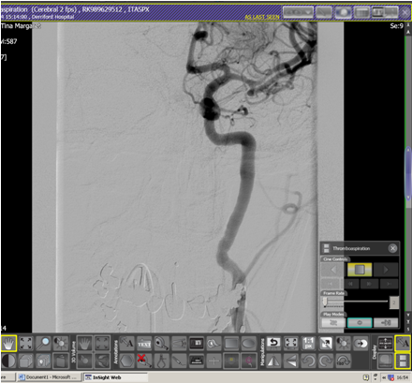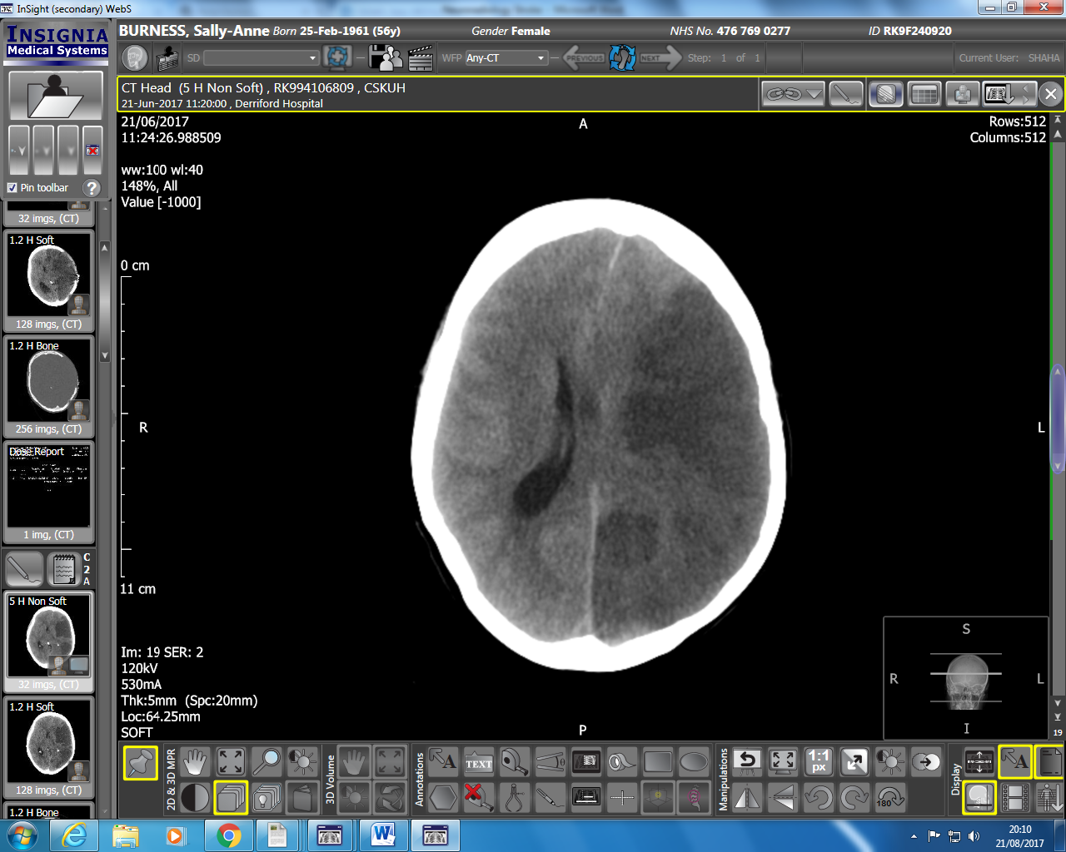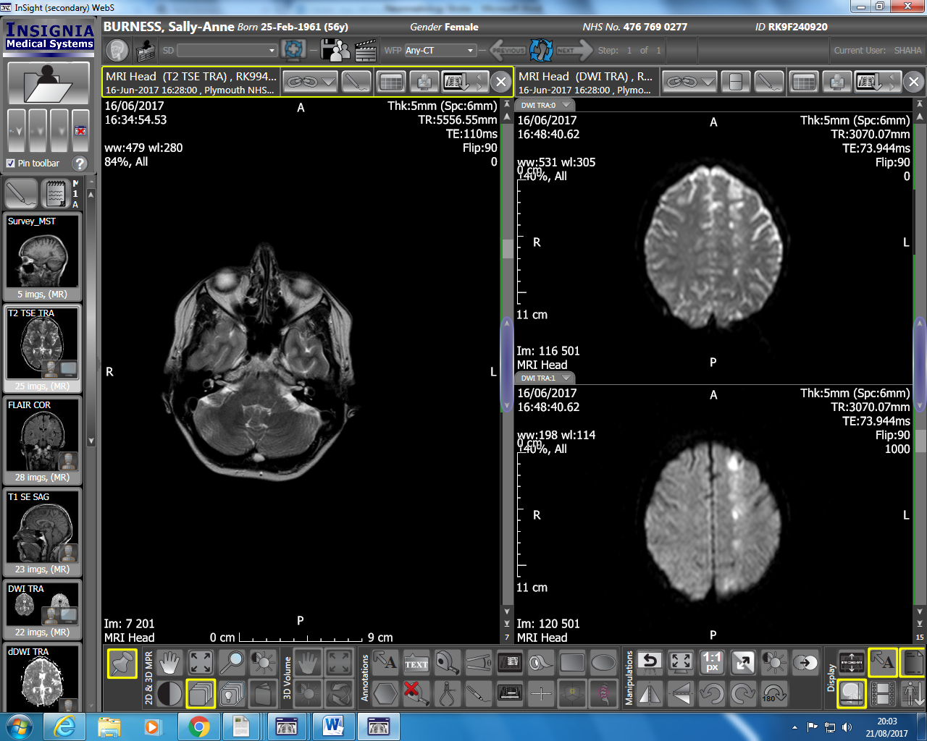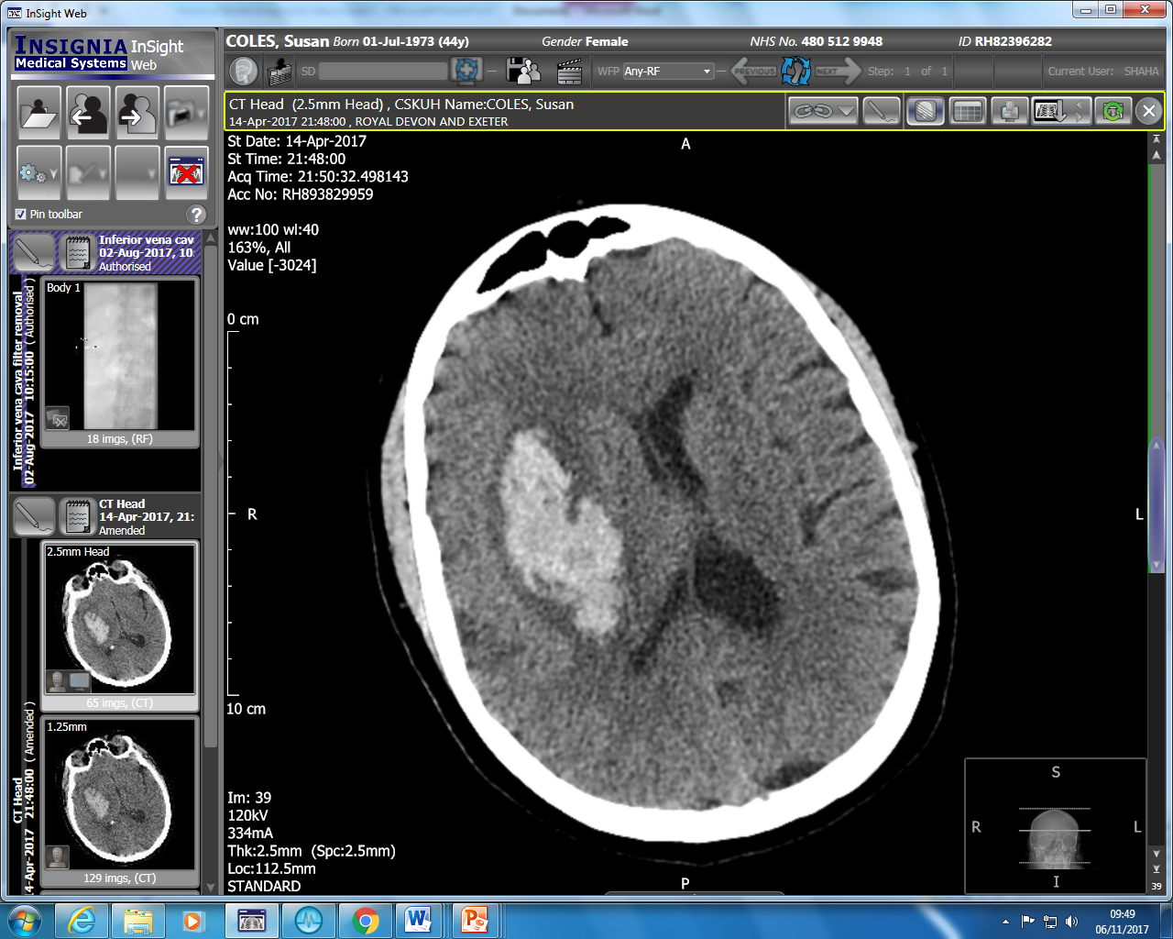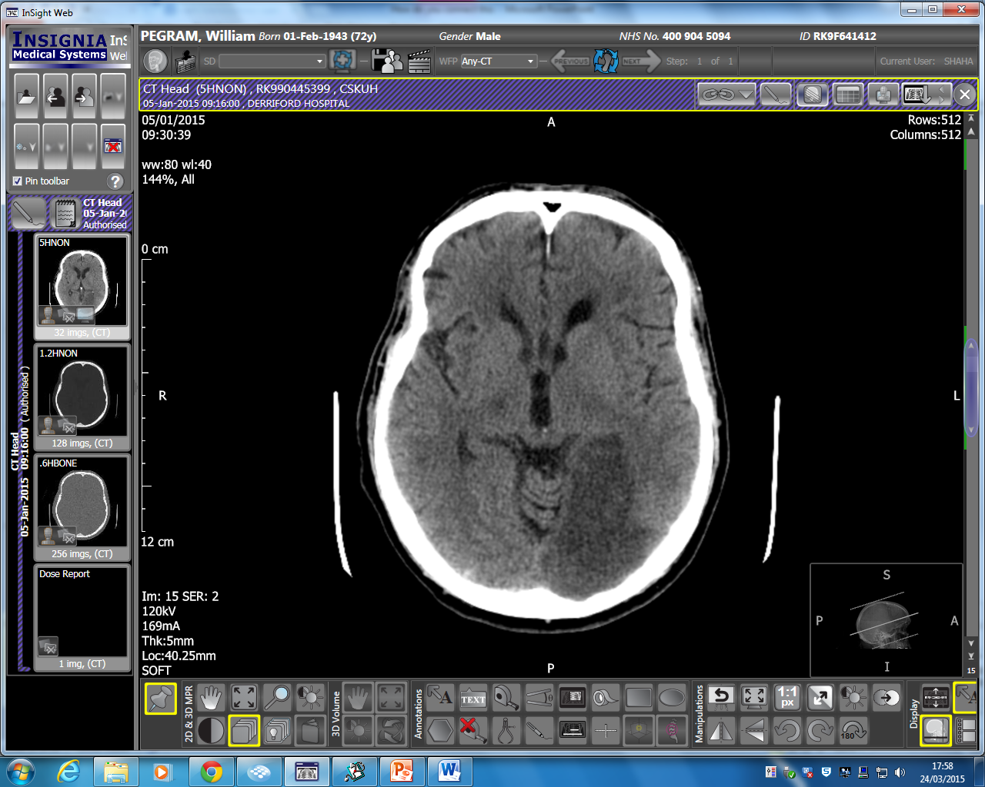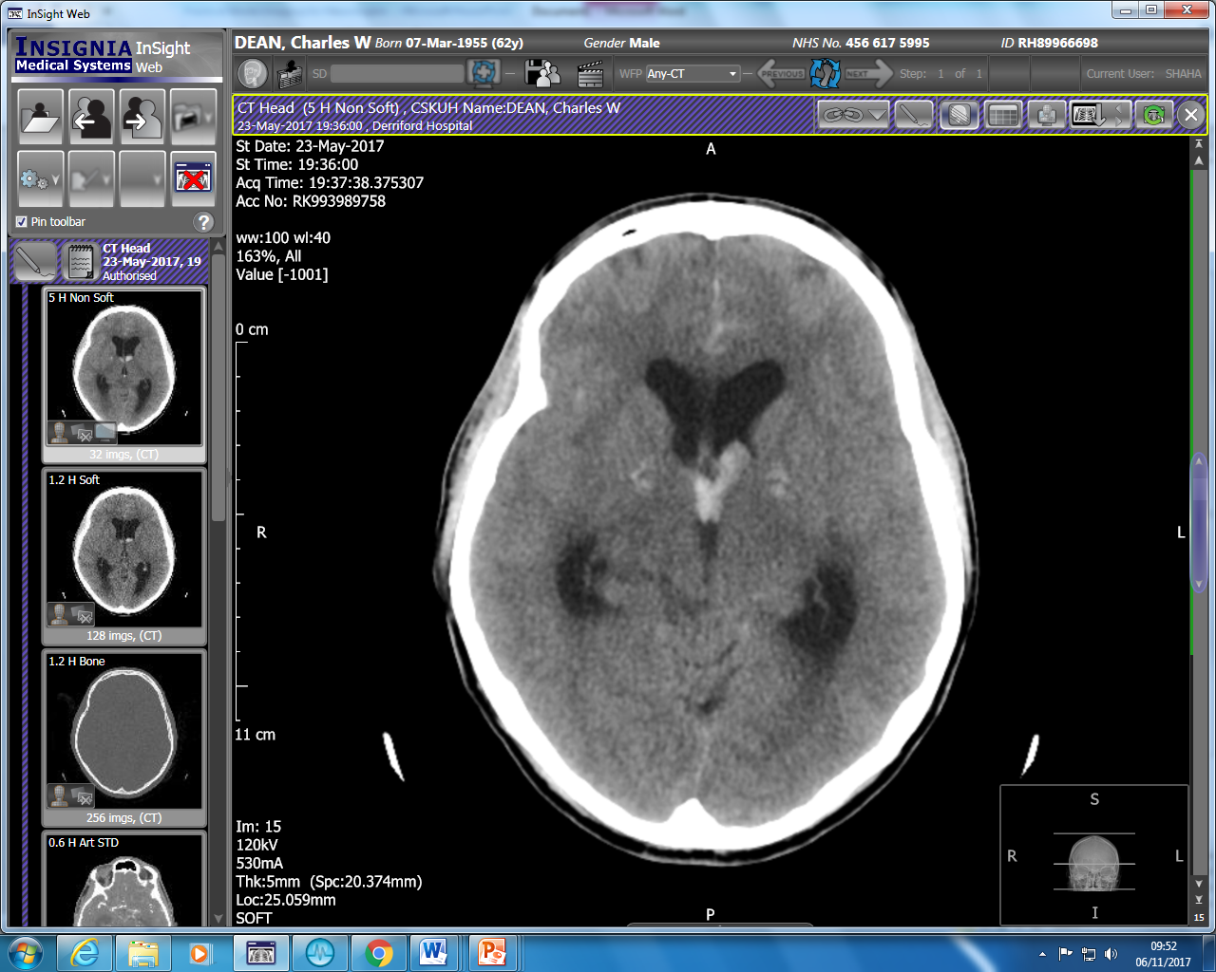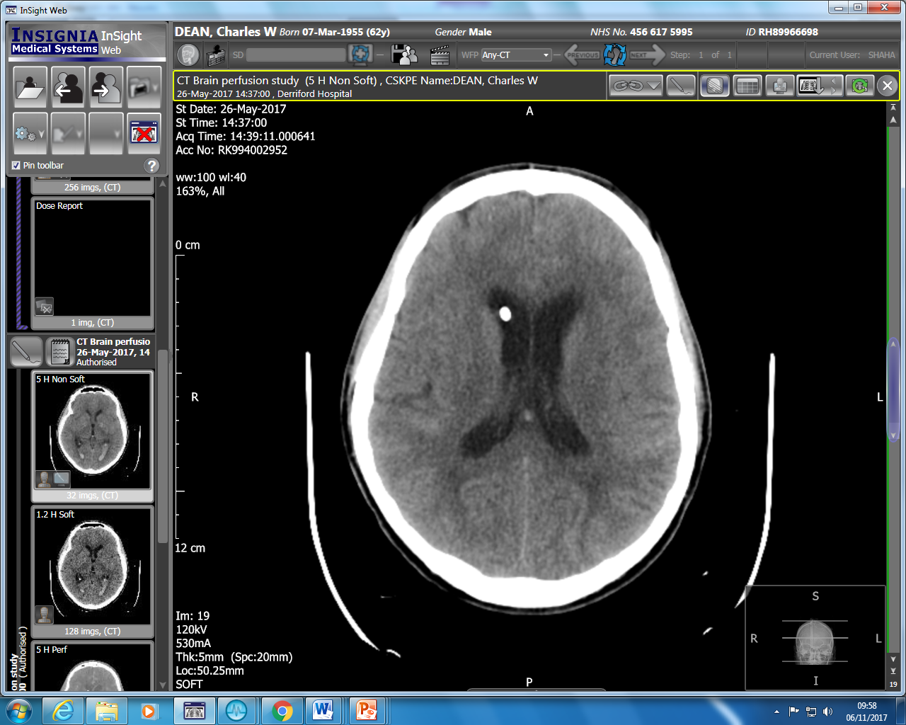
A
B
C
D
E
F
G
H
I
J
A) CTH at 2hrs post onset right hemiparesis. The brain parenchyma is normal but there is a hyperdensity in the left MCA (arrow). B) CT angiogram shows filling defect (where contrast stops filling the vessel). C) Formal angiography for same patient (arrow marks filling defect). D) Angiogram post thrombectomy- the vessel is fully recanalized. E) Malignant left MCA infarct with midline shift and lateral ventricular effacement. This patient should be considered for craniectomy F) DWI MRI brain sequence showing multiple DWI hyperintensities in a ‘string of beads pattern’ suggestive of acute infarcts in the left ICA watershed territory G) Large intra-parechymal haemorrhage arising from the right basal ganglia H) Left PCA territory infarct at 24hrs I) Intraventricular haemorrhage occurring in a patient with subarachnoid haemorrhage. There is hydrocephalus. J) Same patient with intraventricular drain sitting in right frontal horn (arrow). The ventricles are now decompressed.

Stroke Facts and Figures

Outcome: After a TIA or a stroke what’s the risk of having another) stroke? (Coull BMJ 2004)

Approx.:- 10% at 7 days, 15% at 30 days, 20% at 90 days

Risk of subsequent stroke after first year is 5%

 |  | TAC | PAC | LAC | POC
30 day | Dead | 40 | 5 | 5 | 5
 | Dependent | 55 | 40 | 30 | 30
 | Independent | 5 | 55 | 65 | 65
1 year | Dead | 60 | 15 | 10 | 20
 | Dependent | 35 | 30 | 30 | 20
 | Independent | 5 | 55 | 60 | 60

How effective are the secondary preventative Treatments?
Overall, per patient each intervention (secondary prevention) reduces risk by about 20%. Taking secondary prevention as a whole there is approx. 60% relative risk reduction, 10% absolute risk reduction, i.e. numbers needed to treat NNT =10.

NNT for Secondary Prevention

 | NNT to prevent 1 stroke per year
Stroke Unit | 20
Thrombolysis | 10
Aspirin | 50-100
Statin | 70
Antihypertensives | 70
Anticoagulation | 15
Endarterectomy in | 30
2 weeks

NB At an individual level thrombolysis can offer substantial benefit- i.e. it‘s very effective for patients to whom it applies. But it‘s only applicable to approx. 1% of patients.

At an individual level primary prevention is not very effective. However, at a population level it‘s arguably the most effective strategy. Although the numbers needed to treat are large- it‘s possible to impact on a huge number of people, so the overall magnitude of benefit at a population level might be significant
Useful links to on-line stroke training

http://www.stroketraining.org/

http://www.strokeadvancingmodules.org/labyrinth_thrombo/

https://stroke-education.org.uk/

https://eso-stroke.org/eso-guideline-directory/

https://secure.trainingcampus.net/uas/modules/trees/windex.aspx?rx=nihss-english.trainingcampus.net

