
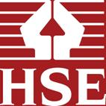

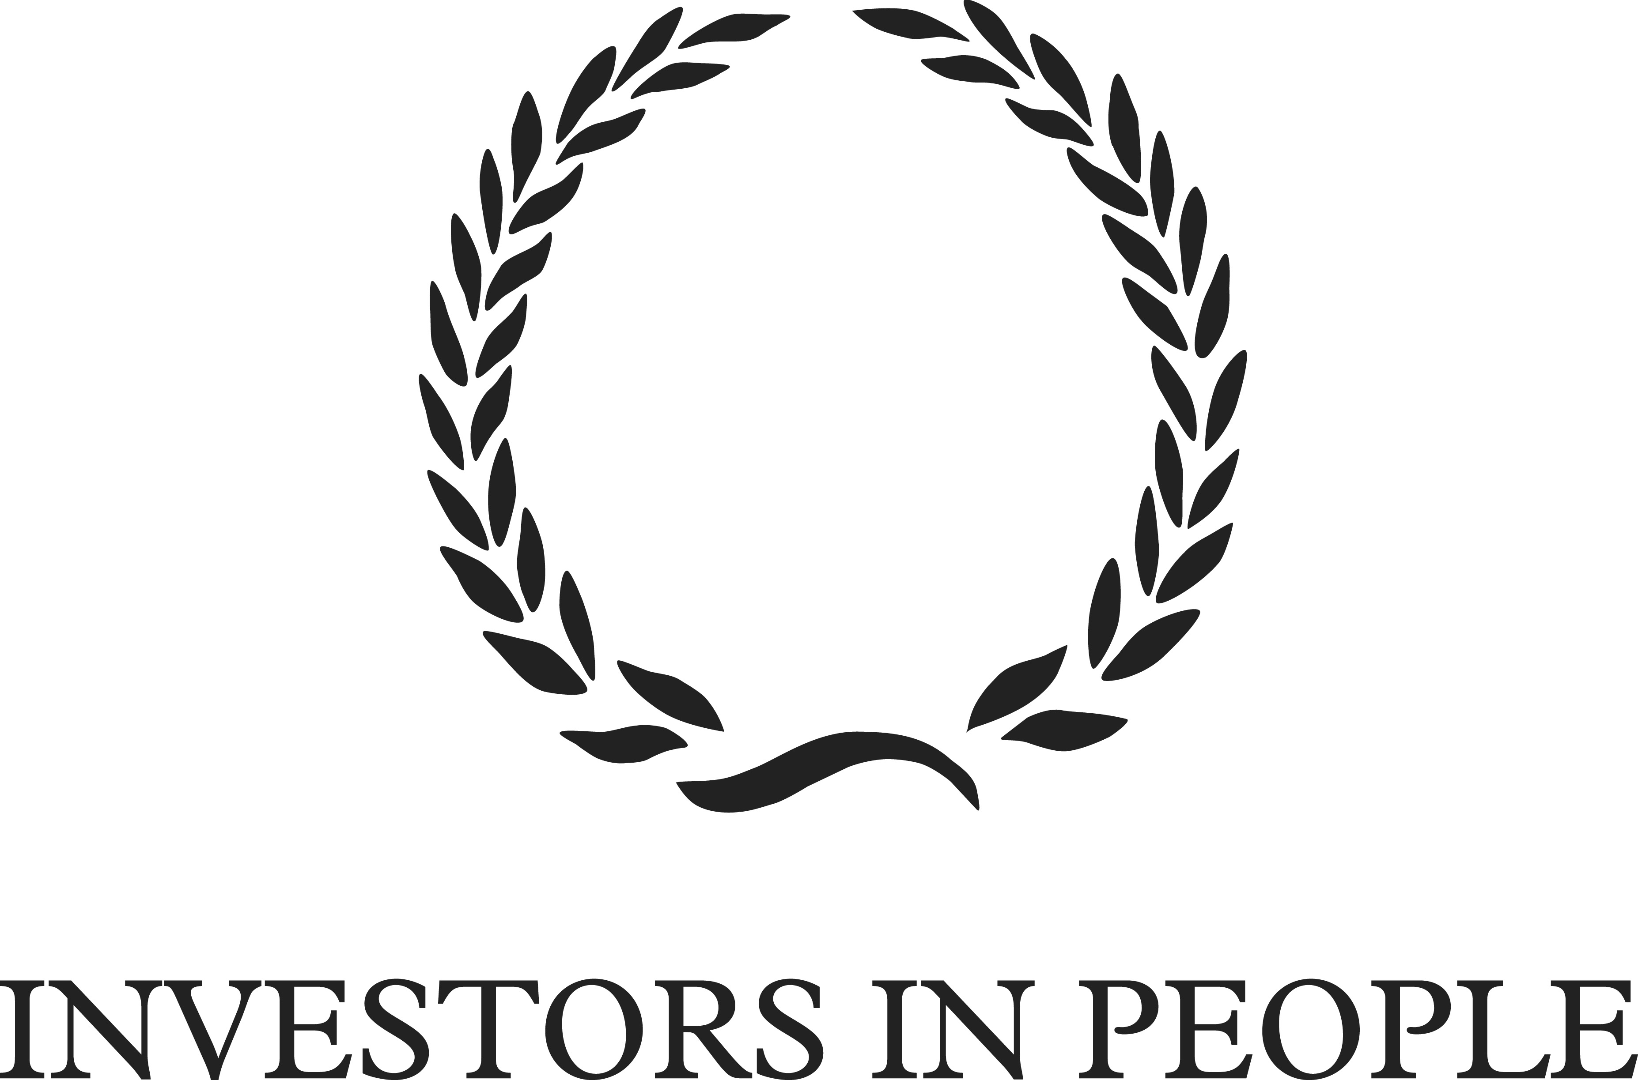

Preventing stress:
Promoting positive manager behaviour

Manager workshop
workbook and feedback form

Managing and communicating existing and future work

In this exercise, you will be working in small groups to consider the potential negative impact a manager can have when staff are under pressure.

- Read the following real examples collected from interviews with employees and managers:

“My manager worked independently, but expected everyone to respond when she said jump. She’d go out and agree things with other people, and come back and say ‘I’ve agreed you will do x, y and z’, without referring to what your workload already is. And so then we had to deliver what she had promised and it was too much. When it came to appraisal time, she said ‘you haven’t got this yet, you are not reaching your targets’”. Local government employee

“Maintaining a balance between monitoring my work, and always ringing up with ‘why haven’t you done this’, or sending emails like ‘What’s happening on this project?’, I think my manager finds hard.” Central Government employee

“I tried to do too many rotas. A rota for coming in, a rota for going on a break, a rota for going upstairs and for having time out. I thought it would be better for the team to know when they were going upstairs and when they were going for breaks, but it didn’t work out like that. They felt under too much pressure, thinking ‘OK, I’m down for a break at 10.15, so I need to finish this call (to the customer) or I’ll miss it’”. Financial manager

“Sometimes I have lost it a bit and just passed on the work instruction. If I am under pressure, I might just pass the work on and pass it down to my team, rather than trying to work as a team to take the task on board and agree some actions”. Healthcare manager

“This week I was made literacy co-ordinator in the absence of someone who is on maternity leave and was the previous literacy co-ordinator. I became the co-ordinator on Monday, and on Tuesday learnt that I had to do a report to the governors the next day on the progress in literacy across the past year. I had no handover, I’ve been in the job two days, and had to report to governors. I asked what I was expected to say, and I was more or less told to blag it. I didn’t want to do that, I wanted to give an informed judgement because it was important and I was new to the role – but I didn’t have enough time to do anything else.” Education employee

“We do have monthly meetings, but my manager packs so much in, it is information overload. I feel it is generally her doing all the talking and then asking for feedback on her performance in the role. I’m not comfortable responding on this directly. I don’t feel the meetings give us a chance to give our input, our thoughts or our ideas.” Financial employee

- Can you think of similar situations from your own experience? Think about a specific situation where you were managed poorly at a time of pressure: a situation where your manager’s behaviour did not help or made things worse. The idea is to talk about one specific situation that you remember rather than talking in general.

- Take it in turns to share these experiences within the group.

Managing and communicating existing and future work

Sub-theme | Do (✓) / Don’t (✗) | Examples of manager behaviour
Proactive work management | ✓ | - Clearly communicates employee job objectives  - Develops action plans  - Monitors team workload on an on-going basis  - Encourages team to review how they organise their work  - Stops additional work being taken on when necessary  - Works proactively  - Sees projects/tasks through to delivery  - Reviews processes to see if work can be improved  - Prioritises future workloads
Problem solving | ✓ | - Deals rationally with problems  - Follows up problems on team’s behalf  - Deals with problems as soon as they arise
Problem solving | ✗ | - Is indecisive at decision making
Participative/ empowering | ✓ | - Gives employees the right level of responsibility  - Correctly judges when to consult and when to make a decision  - Keeps employees informed of what is happening in the organisation  - Acts as a mentor  - Delegates work equally  - Helps team members develop in their role  - Encourages team participation  - Provides regular team meetings
Participative/ empowering | ✗ | - Gives too little direction to employees
© Crown Copyright 2008

Thinking about the situations you have just explored in the group, how would the positive manager behaviours listed above made a difference?
Reasoning/Managing difficult situations

Read the following case study and answer the questions below. This is a real scenario taken from our research study (though the names have been changed).

Samantha (Sam) is a local government employee. The situation began when a new temporary member of staff, called Ashley, started work in Sam’s office. At the time, another team member, Shirley, was on annual leave. When Ashley started working in the office, rather than sit at her own desk, she started using Shirley’s desk regularly. Sam was concerned about this and spoke to Ashley about it. These are Sam’s words: ‘I think one particular day I just sort of said to her, I’d prefer it if you didn’t sit at that desk because that is Shirley’s desk and she’s a bit funny about people using her desk. I said if you could sit at your own desk.’

Although at the time Sam was unaware of any issue, it seemed that Ashley was affected by Sam’s words and spoke to their manager about it. Sam continues: ‘Anyhow she must have really taken offence to it. The next time I had my supervision meeting, the supervision was fine, brilliant and no problem, but then my line managers’ manager (Georgie) came in at the end, and said somebody had expressed the opinion that they thought I was bullying’. Georgie told Sam that it was about the ‘desk conversation’ she had had with Ashley weeks before. Sam continues: ‘I said that I had asked her not to sit at the desk because I know that Shirley is protective of her own environment – she always wanted her desk and everything on it kept perfectly. I said I wasn’t nasty about it at all’. Georgie told Sam that because it had been made official, it had to be mentioned to her. Sam was told to apologise to Ashley. She did this, and Ashley was prepared to accept an apology rather than taking the complaint any further.

Despite the formal procedures being halted, Sam still felt upset about the situation. She continues: ‘After that, because of what had happened, I was really really paranoid about saying anything that might offend’. At her next supervision meeting with her manager, her manager mentioned that she had been quiet, and wasn’t behaving as part of the team. Sam left the supervision meeting still feeling uncomfortable.

Despite Ashley’s departure when her contract ended soon after this, a bad atmosphere in the office remained for the next two or three months.

What were the problems in this case study in terms of the way Sam’s manager behaved?

How would you have managed it differently? Please note down specific behavioural examples:
Reasoning/Managing difficult situations

Sub-theme | Do (✓) / Don’t (✗) | Examples of manager behaviour
Managing conflict | ✓ | - Acts as mediator in conflict situations  - Deals with squabbles before they become arguments  - Deals objectively with conflicts  - Deals with conflicts head on
Managing conflict | ✗ | - Acts to keep the peace rather than resolve issues
Use of organisational resources | ✓ | - Seeks advice from other managers when necessary  - Uses HR as a resource to help deal with problems  - Seeks help from occupational health when necessary
Taking responsibility for resolving issues | ✓ | - Follows up conflicts after resolution  - Supports employees through incidents of abuse  - Makes it clear they will take ultimate responsibility if things go wrong
Taking responsibility for resolving issues | ✗ | - Doesn’t address bullying
© Crown Copyright 2008

Thinking about the case study above, how do the behaviours you identified compare with those listed above:

Which ones did you pick up?

Which ones didn’t you pick up and how would these have helped?

Respectful and responsible: Managing emotions and having integrity

Sub-theme | Do (✓) / Don’t (✗) | Examples of manager behaviour
Integrity | ✓ | - Is a good role model  - Treats team members with respect  - Is honest
Integrity | ✗ | - Says one thing, then does something different  - Speaks about team members behind their backs
Managing emotions | ✓ | - Acts calmly in pressured situations  - Takes a consistent approach to managing
Managing emotions | ✗ | - Is unpredictable in mood  - Passes on stress to employees  - Panics about deadlines  - Takes suggestions for improvement as a personal criticism
Considerate approach | ✗ | - Makes short term demands rather than allowing planning  - Creates unrealistic deadlines  - Gives more negative than positive feedback  - Relies on others to deal with problems  - Imposes ‘my way is the only way’  - Shows a lack of consideration for worklife balance
© Crown Copyright 2008

Reflect on the behaviours listed above and note down:

What are the barriers to showing the positive behaviours and what might cause you to show the negative behaviours? | How could this barrier/cause be overcome?
Managing the individual within the team

Take a few moments to think about what motivates you at work. What makes you come to work in the morning?

Write down the names of 3 or 4 of your direct reports. Think about what motivates each one of them: what makes them come to work in the morning?
Managing the individual within the team

Sub-theme | Do (✓) / Don’t (✗) | Examples of manager behaviour
Personally accessible | ✓ | - Speaks personally rather than uses email  - Provides regular opportunities to speak one to one  - Returns calls/emails promptly  - Is available to talk to when needed
Sociable | ✓ | - Brings in treats  - Socialises with the team  - Is willing to have a laugh at work
Empathetic engagement | ✓ | - Encourages employee input in discussions  - Listens when employees ask for help  - Makes an effort to find out what motivates employees at work  - Tries to see team member’s point of view  - Takes an interest in team’s life outside work  - Regularly asks ‘how are you?’  - Treats all team members with equal importance
Empathetic engagement | ✗ | - Assumes rather than checks employees are OK
© Crown Copyright 2008

Key strengths, development need and actions: Quick View Take Home Points

This exercise aims to bring together what you have learnt about yourself and your management style from the feedback report and the exercises you have worked through. Below is a table comprised of the complete set of management behaviours important for preventing and reducing stress. Take some time to identify three strengths and three development needs from the themes below (these mirror the themes in the framework and the workshop exercises). You can then use this to guide your continued development or as a ‘quick view’ to ensure you are drawing from the behaviours needed to prevent stress and promote a positive team environment.

Behavioural theme | Sub-theme | Description of sub-theme | Strength | Develop-ment need
Respectful and Responsible: Managing emotions and having integrity | Integrity | Respectful and honest to employees
 | Managing Emotions | Behaves consistently and calmly
 | Considerate approach | Thoughtful in managing others and delegating
Managing and communicating existing and future work | Proactive work management | Monitors and reviews existing work, allowing future prioritisation and planning
Managing and communicating existing and future work | Problem solving | Deals with problems promptly, rationally and responsibly
Managing and communicating existing and future work | Participative/empowering | Listens and consults with team, provides direction, autonomy and development opportunities to individuals
Reasoning/managing difficult situations | Managing conflict | Deals with conflicts fairly and promptly
Reasoning/managing difficult situations | Use of organisational resources | Seeks advice when necessary from managers, HR and occupational health
Reasoning/managing difficult situations | Taking responsibility for resolving issues | Supportive and responsible approach to issues
Managing the individual within the team | Personally accessible | Available to talk to personally
Managing the individual within the team | Sociable | Relaxed approach, such as socialising and using humour
Managing the individual within the team | Empathetic engagement | Seeks to understand the individual in terms of their motivation, point of view and life outside work
Action planning and support

This final exercise aims to help you develop a few simple actions you can take over the next few days and weeks to build on your strengths and address your development needs. It also helps you identify the support you will need in order to take the actions you identify.

Strength or Development need | What actions are you going to take? | What will be your first step and when will you take it | What support do you need to take this action and from whom: Manager, Team, Peers, Employer?

Final thoughts

To ensure you get the most out of engaging in this training and receiving feedback on your management behaviour, you might want to consider the following:

- Discussing and following up your feedback results with your staff: It may be helpful to discuss the training and your report with your staff, to get their feedback on what they would like to see you do differently. Your report is completely confidential to you, so it is up to you whether you share it and, if you do, how much you share. Similarly, the responses your staff gave to the questionnaire are confidential to them: when you discuss the report with them, it is important that they do not feel that you are trying to identify who said what. However, despite the bounds of confidentiality, a team discussion with your staff may help you better understand their perspective and generate an action plan to aid your development.

- Discussing and following up with your own manager: The process of training and reflecting on the impact of your behaviour on your staff may have enabled you to see more clearly where the sources of stress lie for your team. Where these are things you can change yourself, you are now in a great position to make positive changes. In some cases, you may find that you need to discuss the situation with your own manager to explore ways in which the sources of stress for the team can be tackled. You may even want to discuss how your manager’s behaviour impacts on you and your staff – though, of course, this will need to be handled sensitively!

- Using the group of managers attending today’s workshop as a support group: The great advantage of going through the training with a group of managers is that you have all received an upward feedback report and you all know about the key behaviours for preventing stress, so you are in a great position to help one another with implementing any changes you may want to make. If you find you are struggling with any particular aspect of the behavioural framework or need to talk about a particular situation, you may find that it helps to contact others in the group and discuss it with them. You may even want to agree a process with one or more of the others on the workshop to help you support each other with taking the actions you have identified in the last exercise: for example, a quick phone call every so often may be the reminder/motivation you need to keep on track!

Further tools and resources

You may find the following useful for gaining more information about stress and mental health at work:

- Information and resources may be available through your employer, for example from: Occupational Health, Employee Assistance Programme/Welfare Service, Human Resources
- Health and Safety Executive website: for information about the Management Standards and resources on stress management: www.hse.gov.uk/stress
- SHIFT Line Manager's Resource: for practical guidance on managing and supporting people with mental health problems in the workplace: www.shift.org.uk
- Mental Health Foundation and Mind websites: for information about mental health issues: www.mentalhealth.org.uk and www.mind.org.uk
- The Shaw Trust online resource for managers to help them support staff with mental health problems: www.tacklementalhealth.org.uk

Further Reading.

Michael West Blog – Are we Supporting or Sacrificing Staff…;
https://www.kingsfund.org.uk/blog/2015/10/are-we-supporting-or-sacrificing-nhs-staff

HSE Workplace Absence Statistics; http://www.hse.gov.uk/statistics/overall/hssh1617.pdf

How to work without Stress, Centre for Creative Leadership.
https://www.ccl.org/articles/leading-effectively-articles/banish-stress-stop-ruminating/
and
https://www.ccl.org/wp-content/uploads/2015/04/WakeUp.pdf

Guidance on the Prevention and Management of Stress at Work; NHS Employers
https://www.nhsemployers.org/-/media/Employers/Documents/Retain-and-improve/Guidance-on-prevention-and-management-of-stress-at-work-final-for-website-16-Oct.pdf

Preventing stress: Promoting positive manager behaviour

Manager workshop feedback form

We would be very grateful for your feedback on today’s workshop.

Date | Tutor
Your name (optional)

Please answer the following questions on a scale of 1 - 5 where 1 is the least favourable response and 5 the most favourable response.
 | 1 | 2 | 3 | 4 | 5
1. To what extent did the workshop achieve its aims:
- To explore the importance of positive manager?

- To increase awareness of your own behaviour?

- To equip you with the tools to further enhance and/or develop your skills?

2. How would you rate your awareness and understanding of your management behaviour:
- Prior to attending today's workshop?

- After attending today's workshop?

3. To what extent will you be able to apply what you have learnt in your work?

4. What did you find the most useful part of the workshop?

5. What did you find the least useful part of the workshop?

6. How could the workshop be improved?

Please answer the following questions on a scale of 1 - 5 where 1 indicates little or none and 5 indicates a lot.
 | 1 | 2 | 3 | 4 | 5
7. How much management development or management skills training have you received prior to today?

8. To what extent did your manager play a role in encouraging you to participate in this project and attend today's workshop?

9. How long have you been in a management position (managing staff)? | ………………. years
10. What further support and/or training do you need to develop your knowledge and skills in the areas covered by the workshop?

Please answer the following questions on a scale of 1 - 5 where 1 is the least favourable response and 5 the most favourable response.
 | 1 | 2 | 3 | 4 | 5
11. Did the tutor demonstrate a thorough knowledge of the subject?

12. Was the tutor helpful and responsive to individual needs?

Any further comments on the workshop?

Thank you very much for your feedback

